W300D-How to set a DMZ host?
Product line: ADSL Question category: function configuration

Q: Why do we want to configure DMZ host?
A：1. In the router set port mapping, port mapping can’t be access remotely, then you can try to open the DMZ host, if you open the DMZ host, the remote can access the port corresponding to the normal service.
2. Don’t know the port number of some kinds of application servers so that you can’t set port mapping, such as network cameras, some database software, etc., then you can open the DMZ host.
3. Can’t play some games when the normal operation (e.g. StarCraft) and you can land normally, but can’t field a team, then you can open the DMZ host.
4. Some special sites cannot open or can’t operate normally, such as certain online banking can’t be transferred, can‘t enter the verification code, etc. You can try to set the DMZ host.

The topology is as following:
I. Physical connection:
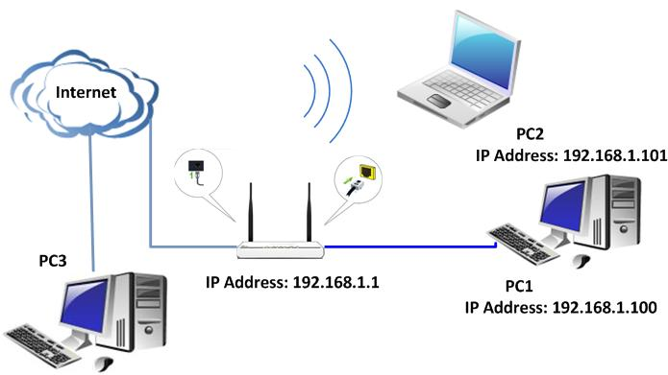
II. Login to the management page of the router:

1. Open a web browser (IE, Firefox, Safari, etc.) and find the address bar, leaving it blank before typing in 192.168.1.1, and then press enter.
(Care: The address bar is in the most top of the web page after opening web browser).
2. Click on Advanced Settings in the following page.
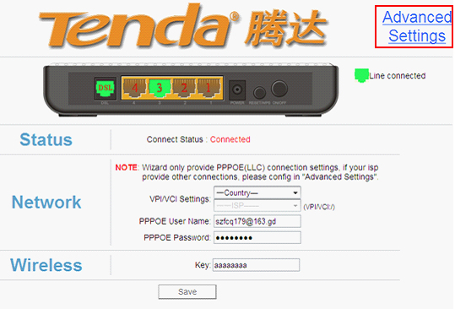
3. You will see the following page.
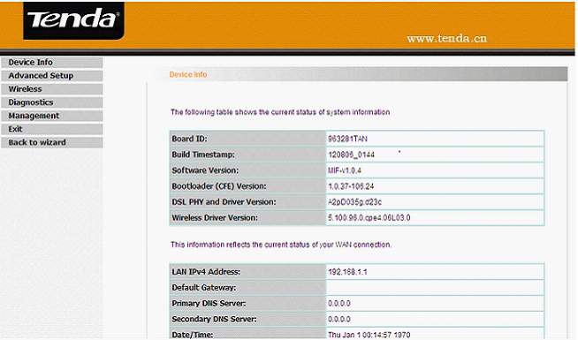

4. Please click Advanced Setup->NAT →DMZ host .
In the blank of DMZ Host IP Address, please type in the IP address of the computer which you want to achieve the communication with Internet without limit.Remember to click on Save/Apply to save the settings.

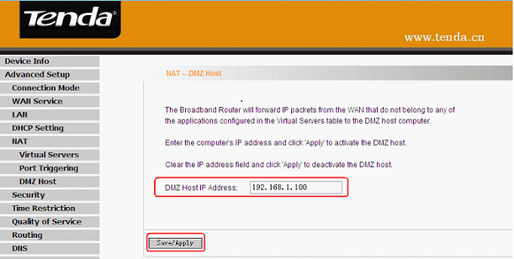

For example, if you want the PC with an IP address of 192.168.1.100 from your router’s LAN side to be shared by Internet users for data and other resources. For configurations, follow the instructions below:
Click “Advanced Setup”----“NAT”---“DMZ Host” to configure the page below:

Supposing that the router’s WAN IP address is 183.37.227.201, then the Internet user only needs to enter http：//183.37.227.201 in Web browser address field to access your Web server.

